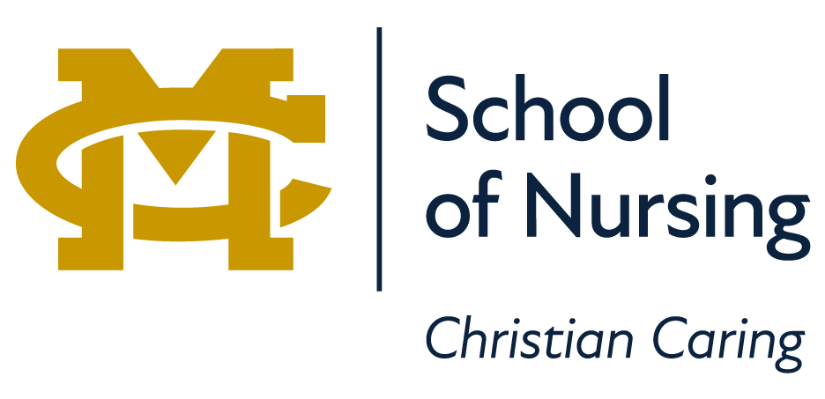

School
Of
Nursing

Online Student
Supplemental Handbook
2023-2024

Dear Online Nursing Student,

Welcome to the Mississippi College School of Nursing (MCSON) online programs! We are thrilled that you are pursuing your education with us and we look forward to working with you to achieve your degree. Mississippi College (MC) and the MCSON are committed to promoting success for all students.

Below is the MC institutional mission and the MCSON mission:

MC Mission Overall | MCSON Mission
Pursuit of academic excellence, stimulating the academic development of students through concentrated studies in specific academic fields, whilst providing opportunities for service. | The mission of the MCSON is to prepare healthcare professionals to care for diverse populations by demonstrating Christian Caring, utilizing informed clinical judgments, and practicing safe client-centered care.

Online learning is evolving constantly, and here at MCSON, we strive to provide the best quality instruction through innovative and current systems and processes. Compared to traditional learning, online courses provide the flexibility that many students need when choosing to further their education. Our programs require that you, the student, are self-motivated and eager to learn and adapt to online styles in order to gain the full benefit from our courses. We realize that, for some, learning in an online format may be a new concept. In this handbook supplement, we will provide some tips for success for our online students.

1. General tips
a. Register for courses on-time.
b. Pay for courses by the session deadline to avoid being unintentionally dropped from those courses.
c. Open your course on Day 1 of each session to ensure access and to begin reviewing the course.
d. Reach out to your instructor or program director whenever you have questions or need clarification. Contact information is listed on the course syllabus.
e. Review the student orientation course in Canvas as soon as you enroll in your first online course. Take your time and work through each orientation module, as this will answer most questions you have.
BSN & BSPH Student Toolkit- https://mississippicollege.instructure.com/courses/5767
MSN Student Toolkit- https://mississippicollege.instructure.com/courses/3384
f. All school-related communication will occur through your mc.edu email account, so check this once a day at minimum.

2. Review the General MCSON handbook:

https://nursing.mc.edu/students

3. Access the link below for the MC7 Online Student Guide and Handbook;

https://www.mc.edu/offices/registrar/mc7-online-student-guide

4. Navigate to the Leland Speed Library and begin reviewing the numerous resources available. The Leland Speed Library is committed to providing the best university-level library resources and services to its students, faculty, and course developers. For online students and faculty, "going to the library" means using this high-tech environment to:
a. search free and fee-based online databases effectively for scholarly information.
b. get assistance from professional librarians via e-mail, phone, or chat.
c. link full-text publications to a laptop, mobile phone, tablet, or hand-held book reader (as author and publisher rights allow)
d. access inter-library loan services and use local libraries for publications not available in digital formats.
e. evaluate the contents of digital and print publications for authenticity, accuracy, objectivity, currency, and completeness of coverage of the subject.
f. integrate information into their research and writing.
g. use information literacy skills for their own lifelong learning.
h. promote information literacy skills

The MC library: Leland Speed Library may be accessed from the home page or by the following link- https://library.mc.edu/

Lib Guides are available for each of your courses and contain additional resources for weekly assignments. The library has a wealth of videos that supplement your learning. The Alexander Street Press-Nursing Video Collection includes 849 Nursing videos, which are part of a larger Health Sciences collection. Films on Demand-Nursing Video Collection includes 5200 streaming videos in all areas of Nursing

Our Library directly supports online teaching and learning with both innovative and traditional library services, resources, and online technologies. To access the library database, click the link below.
https://library.mc.edu/collections-resources/databases/

5. Click this link to learn more about our Learning Management System, Canvas:
How do I navigate a Canvas course?

6. Click this link to learn how to access your textbooks within each course:
Student Instructions for E-Book download.docx

7. Review some of the core rules of Netiquette:

Rule 1: Remember the Human
Rule 2: Adhere to the same standards of behavior online that you follow in real
life
Rule 3: Know where you are in cyberspace
Rule 4: Respect other people's time and bandwidth
Rule 5: Make yourself look good online
Rule 6: Share expert knowledge
Rule 7: Help keep flame wars under control
Rule 8: Respect other people's privacy
Rule 9: Don't abuse your power
Rule 10: Be forgiving of other people's mistakes

Follow the link to access a description for each rule. http://www.albion.com/netiquette/corerules.html

8. Review the required health compliance requirements for clinical participation.

9. You will be taking online tests in several courses throughout your program. Here are some general tips for taking online tests:
Before Starting the Test
- Disable all pop-up blockers. Or set them to allow pop-ups for your learning platform. Tests sometimes appear as pop-up windows, and a pop-up blocker may prevent the test from displaying properly. You may need to turn off pop-up blockers in your browsers and in other software such as Google or Yahoo toolbars and virus protection programs.
- Clear Browser cache. Before you take a test, clear your browser’s cache. For instructions on clearing the browser cache, locate the Help area of your browser program and search for “browser cache” or “clear browser cache” to get instructions for your specific browser.
- Clear Java cache. To help prevent some testing issues, you may want to clear your Java cache before each test. For Windows 7, Vista, Windows XP, Windows 2000/2003 users running Java version 6, visit the Java website to learn how to clear java cache (Links to an external site.) and follow the instructions provided by Java.
- Close all other programs running on your computer before taking a test. Having multiple programs open may cause problems that may result in loss of quiz data.
- Make sure you use a compatible browser when working in an online learning environment.
- Some tests may only be taken once. Do not begin a test until you are ready to.

During the Test
- Do not use your web browser's Back or Forward buttons when working in an online learning environment, and when taking a test.
- If the test is set to display one question at a time, make sure that you have selected the best answer before moving on to the next question. Use the navigation arrows to advance to the next question.
- Focus on completing the test. Do not open any additional software applications, check email, or browse the Internet in other windows.
- Do not leave the computer idle while a test is in progress. Your current session will automatically end after a period of inactivity.
- Beware of software updates and virus scans. If you have programs such as automatic software updates or virus scans set to run at a particular time, do not take the test during a time when software updates are scheduled to occur.
- Do not resize or refresh the screen after loading the test. Make sure it is the size you want before going into the test. Most browsers refresh the page when you resize the screen. This means it will reload the quiz and may prohibit you from taking the test.
- The majority of questions in assessments are auto-graded. Essay, file response, and short answer questions are not auto-graded. If an assessment contains these question types, your instructor will review the questions and manually provide a score. The grade for the assessment will not be immediately available after the assessment is submitted.

10. All online programs utilize E-Value as the repository for health compliance documents, key element assignments for every course, and personal documents such as resumes, CVs, goal statements, etc. Access the link below for more information on logging clinical time and activities.
https://mississippicollege.instructure.com/courses/3384/pages/e-value?module_item_id=42030

11. Policy regarding email response time and assignment grading and feedback:
a. Faculty teaching in the RN-BSN and MSN programs will acknowledge receipt of email correspondence from a student within 24 hours and respond appropriately to that email as soon as possible (if an email is received Friday afternoon and is not urgent, faculty may not respond until the following Monday).
b. Assignment grading and feedback will occur within 72 hours of assignment submission by the student. Keep in mind, submission of an assignment on Thursday may be graded sooner than an assignment on Sunday at 11pm.

12. Attendance Policy for Online Students:
According to Academic Affairs Policy 2.10, there is an expectation that students attend class, and if they fail to do so it can result in an “F” for the course. Please review the MC requirements for class attendance. Online and hybrid classes require at least three (3) log in events weekly to participate in the online learning environment and to validate course engagement. Students must be logged in to complete assignment work in a timely manner.

13. Plagiarism falls under the Academic Honesty Policies for Mississippi College and the School of Nursing. If a student is suspected of plagiarism, he/she will be contacted by the course faculty and/or the program director and will be required to complete the following by a specified date and time:
1) Submit a 250-500-word statement affirming your knowledge of academic integrity requirements.
2) List the MC and SON policies that relate to academic honesty and plagiarism.
3) Write a short statement affirming your commitment to personal and professional integrity.
Academic integrity is taken very seriously at Mississippi College. The penalty for the first offense is given with the understanding that this behavior will not be repeated. A second offense may result in dismissal from the university.

14. Instructor feedback is a primary method of communication provided in all online courses. It is in the students’ best interest to receive and utilize instructor feedback. If a student elects to not receive direct instructor feedback, the student must submit this request in writing. The instructor will then communicate with the student only through group emails to the class and through course announcements. If the student fails assignments or the course, the SON has written confirmation that the student did not wish to receive any feedback or additional reminders or inputs from the instructor.

Online Program Contact Information:

Dean of the School of Nursing  Dr. Kimberly Sharp, PhD, RN  Professor  ksharp@mc.edu | Director of Online Development  Karen Ivie, MSN, RN, CNL-BC  Assistant Professor of Nursing  kdivie@mc.edu
RN-BSN Program Director  Dr. Lynn Buckalew, PhD, RN  Associate Professor of Nursing  buckalew@mc.edu | Chair of Undergraduate Program  Rick Lewis, MSN, RN, CEN  Assistant Professor  lewis13@mc.edu
MSN Program Director  Jeanne Bernier, MSN, RN, CNL-BC  Instructor  jabernier@mc.edu | Chair of Graduate Program  Dr. Deborah Welch, PhD, RN, CNE  Assistant Professor  dwelch@mc.edu
Nursing Program Specialist  Cindy Greer  Greer05@mc.edu | Health Compliance Coordinator  Deborah Bolian-  bolian@mc.edu
Records Coordinator
Carol Clendenon
clendeno@mc.edu

